**Classroom Activity​: Write a function that iterates over the properties of an object and prints out each key-value pair.​**

**​**

**Code-**

​

const exampleObject = {

name: "Alice",

age: 30,

city: "Wonderland"

};

for (let key in exampleObject) {

if (exampleObject.hasOwnProperty(key)) { // Check if the property is directly on the object, not inherited

console.log(key + ": " + exampleObject[key]);

}

}

**Output-**

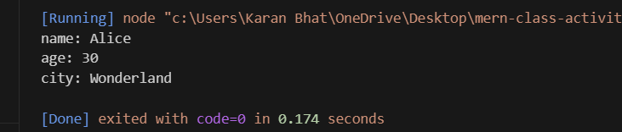

**Execution-Steps:**

* Create a JavaScript file with any name
* Write the code
* Run the code in the terminal using F5 or right click and go to inspect and you can get the output in the console as well.